Reproducible Sparse-Concept and Calibration Diagnostics for Knowledge Tracing
Khanh-Trinh Nguyen¹, Tuan Dao Minh¹, Duong Nguyen Tien¹, Chi Thanh Nguyen², and Van-Hau Nguyen¹,*
¹ Hung Yen University of Technology and Education, Hung Yen, Vietnam
² Academy of Military Science and Technology, Ha Noi, Vietnam
Email: trinhnk@utehy.edu.vn (K.-T.N.); tuanymc@utehy.edu.vn (T.D.M.); duongnt@utehy.edu.vn (D.N.T.); thanhnc@ioit.ai.vn (C.T.N.); haunv@utehy.edu.vn (V.-H.N.)
*Corresponding author
Manuscript received Month date, 2026; revised Month date, 2026; accepted Month date, 2026

Abstract—Knowledge Tracing (KT) systems that skip, remediate, or advance practice typically consume a predicted probability rather than an area-under-the-curve (AUC) score, so population ranking can look acceptable while probabilities are poorly calibrated on rarely practiced knowledge components (KCs). We specify a train-only sparse-concept evaluation protocol that uses learner-based primary reporting (the complementary temporal split is leakage-audited in Supplementary Table S10), explicit cold-start definitions, occupancy-aware reporting, 15-bin expected calibration error (ECE), Brier score with the Murphy decomposition (uncertainty − resolution + reliability), reliability diagrams, and L1–L7 leakage control. The protocol is applied to three public logs (ASSISTments 2012, Junyi Academy, and XES3G5M) with IRT, DKT, and a local Transformer KT baseline (T-KT; not SimpleKT [4]); official SimpleKT is scored on ASSISTments AUC/ECE only. Lower KC training frequency does not universally degrade discrimination: Junyi’s exercise-level operational identifier (ucid) yields no learner-based sparse stratum, and XES3G5M T-KT ECE is essentially flat (0.1176, 0.1129, 0.1254), whereas ASSISTments 2012 T-KT ECE rises from 0.114 on dense KCs to 0.228 on sparse KCs (Limited occupancy, N≈415). A frozen review artifact and a one-command rebuild of the diagnostic tables from frozen summaries accompany the protocol; a locked simulated gate at τ=0.7 is reported only as a decision-error probe (Supplementary Tables S3–S6), not as a primary contribution. This is not a classroom intervention.
Keywords—knowledge tracing, calibration, sparse concepts, learning analytics, evaluation protocol, leakage audit

I. INTRODUCTION
Adaptive practice platforms and intelligent tutoring systems use Knowledge Tracing (KT) to estimate a learner’s mastery of a skill and to decide whether to skip, remediate, or advance practice [1]–[3]. Those systems rarely consume a population area-under-the-curve (AUC) statistic. They consume a predicted probability p, which is then compared with a threshold τ. If p≥τ, the platform typically withholds additional practice on that skill. The operational chain is therefore population AUC → predicted probability → calibration → threshold-based educational decisions, with particular diagnostic risk on sparsely trained knowledge components (KCs).
KT evaluations typically report population AUC and accuracy [4], [5]. Those metrics rank models, but they can conceal miscalibration on low-frequency KCs—skills with little training-fold evidence—because most test events lie on dense, frequently practiced concepts. A model can discriminate well in aggregate and still assign overconfident probabilities on the sparse tail. When a fixed threshold is applied to p, that overconfidence appears as an advance decision followed by an incorrect next response. We term this the false-advance rate (FAR). Section III defines FAR as P(y=0 | p≥τ); y denotes observed next-response correctness, not latent mastery truth.
This paper treats that mismatch as an evaluation problem for educational technology, not as a reason to propose another KT architecture. The study is organized around an estimability check (does a sparse stratum exist under the platform’s KC definition?) and three research questions. RQ1: Does lower KC training frequency systematically degrade predictive discrimination? RQ2: How does probability calibration vary across train-only KC-frequency strata and datasets? RQ3: Under what dataset and concept conditions are sparse-concept calibration diagnostics estimable and informative, and are the conclusions robust to alternative train-only frequency cuts?
The empirical answers are bounded. Lower KC training frequency does not universally degrade discrimination: on XES3G5M, sparse AUC is higher than dense AUC for DKT and T-KT. Calibration can, however, become less reliable in some sparse-concept regimes. On ASSISTments 2012, T-KT expected calibration error (ECE) increases from dense to sparse KCs (Limited sparse support, Section IV.D). The same ECE gradient is absent on Junyi, where the learner-based sparse stratum is empty, and is essentially absent for T-KT on XES3G5M. Two alternative train-only frequency cut grids leave that ASSISTments T-KT rise positive (Supplementary Table S7). A locked gate at τ=0.7 is a simulated decision-error probe (Supplementary Tables S5–S6), not RQ3. We therefore do not claim that sparse KCs always fail, and we do not claim a causal effect of training frequency on calibration.
Contributions are conservative: (i) a train-only sparse-concept evaluation protocol with learner-based primary reporting (temporal split: leakage audit only, Supplementary Table S10), explicit cold-start definitions, occupancy-aware reporting, and L1–L7 leakage control; (ii) per-stratum calibration diagnostics using ECE, Brier decomposition, and reliability diagrams, showing dataset-dependent rather than universal sparse-calibration vulnerability; (iii) a reproducibility artifact with frozen scripts and configuration and a one-command rebuild of the diagnostic tables from frozen summaries. We do not propose a new KT architecture, a new calibration algorithm, or a classroom intervention. Graph and contrastive KT models are out of scope and are not scored.

II. LITERATURE REVIEW

A. Knowledge Tracing and benchmark models
Knowledge Tracing (KT) models a learner’s evolving proficiency from historical interactions in order to predict the next response [3]. Classical approaches include Bayesian Knowledge Tracing (BKT), which tracks a latent mastery state for each skill [1], and item-response theory (IRT), of which the one-parameter Rasch model is the canonical form used in this study [6]. Deep Knowledge Tracing (DKT) replaced hand-specified mastery dynamics with a recurrent sequence model and established the modern next-response prediction task [2]. Attention-based successors, including context-aware attentive KT [7] and SimpleKT [4], retain that task while substituting self-attention for recurrence. SimpleKT [4] is not the T-KT model; official SimpleKT is scored on ASSISTments AUC/ECE only. Benchmarking libraries such as pyKT have standardized preprocessing and comparison, and have shown that evaluation choices can distort reported discrimination [5]. Across this line of work, the primary reported statistic remains population AUC. Uncertainty-aware models such as UKT represent knowledge states as distributions [21]; they are architecture proposals evaluated mainly on population ranking, not a train-only frequency-stratum decision audit.

B. Evaluation rigor and leakage in KT
Standard KT benchmarks emphasize overall AUC after a fixed preprocessing recipe [5]. pyKT documents that evaluation choices can inflate discrimination by about 8–13 percent. This paper extends that hygiene to train-only frequency strata and calibration: every bucket, difficulty descriptor, and reporting threshold is fit on the training fold (or selected on validation) and then applied to test. Graph-based Knowledge Tracing [8] and contrastive learning for KT [9] are related literature only; they are not trained or scored here and are reserved for later studies.

C. Sparse-data and cold-start problems
The term “sparse” is used in several incompatible senses in the KT literature. This paper distinguishes four. (1) Sparse attention: sparseKT applies k-sparse attention so that only a subset of historical interactions receives nonzero weight [16]. (2) Sparse KC frequency: a knowledge component with few training-fold observations. (3) New-student cold start: prediction for learners who have little or no interaction history at test time [17]. (4) Concept-level cold start: a knowledge component with zero training-fold frequency, regardless of whether the learner is new. The XES3G5M log exhibits a long tail in which a small set of dense KCs dominates event volume [20].
These four problems are not interchangeable. sparseKT-style sparse attention is not equivalent to low-frequency KCs: attention can be sparsified on a frequently practiced skill. New-student cold start is not the same as concept-level zero-frequency cold start: a previously observed learner may still encounter a concept that never appeared in the training fold. The protocol in Section III operationalizes (2) and (4) through train-only KC-frequency strata with an explicit strict cold-start group (f=0).

D. Calibration and educational decision support
When predicted probabilities are consumed as educational decisions, ranking is not a sufficient evaluation [10]. Calibration asks whether the predicted probability p matches the empirical frequency of a correct next response. Expected calibration error (ECE) is the usual bin-wise summary of that mismatch [12]; modern neural networks can remain poorly calibrated even when they discriminate well [11]. The Brier score [13] and Murphy’s reliability–resolution–uncertainty partition [23] (calibration vs. refinement [14]) separate miscalibration from task difficulty, and reliability diagrams display the same probability-level comparison. Complementary post-hoc work recovers per-item discrimination (AUC) after a frozen KT backbone [15]; it is not an ECE or FAR audit. Probability-level evaluation of this kind is still typically reported on the pooled population, not on train-only frequency strata. Selective-prediction layers defer the most uncertain next-response scores to a teacher [22]. Abstention is complementary to a locked global threshold: this study does not abstain, and it reports the false-advance rate of the advances that a fixed τ would still make, stratified by train-only KC frequency.
Existing KT benchmarks mainly emphasize aggregate discrimination. Mastery-threshold false positives [24] and first-attempt skill evaluation [25] address related decision errors, but they do not jointly report train-only KC-frequency occupancy, ECE, and a locked-τ FAR. Sparse frequency, calibration, sample support, and threshold-based decision error are rarely examined together. This study keeps standard models and reports those four quantities jointly, so that a population AUC result can be read as an educational-technology decision rather than only as a leaderboard rank.

III. MATERIALS AND METHODS

A. Datasets
We use three de-identified public logs after a common interaction schema: ASSISTments 2012 [18], [5], Junyi Academy [19], and XES3G5M [20]. Table 1 reports post-processing counts: processed learners, processed KCs, processed interactions, and learner-based test events. Exact processed interaction totals are 2,657,490 (ASSISTments 2012), 16,215,567 (Junyi Academy), and 6,413,353 (XES3G5M). Preprocessing drops rows with missing learner, KC, or label identifiers, binarizes correctness, parses timestamps, and keeps learners with at least two interactions. Those filters—not the raw public dumps—are what Table 1 counts.
Provenance. ASSISTments 2012 is the 2012–2013 public release with affect [18], documented for KT use in pyKT [5]; each retained row already carries one skill_id. Junyi Academy is the Kaggle Online Learning Activity Dataset [19] (not Junyi2015); the operational KC field is ucid (unique content/exercise ID, not a skill tag); that tagging choice, not a processing error, is why the learner-based sparse bucket is empty under the pre-specified cuts. XES3G5M [20] is loaded from the authors’ kc_level split: train_valid_sequences.csv and test.csv are concatenated and flattened to one row per unmasked sequence position (padding and invalid labels dropped).
XES3G5M counts. The original dataset paper reports 18,066 students, 7,652 questions, 865 KCs, and 5,549,635 question-level interactions [20]. Table 1 lists 865 KCs and 6,413,353 valid KC-level rows: flattening still expands multi-KC questions into one row per listed concept, but padding tokens are excluded. Unique item_id is 7,652. Learner-based fold-0 test events are 1,282,422.
Table 1. Post-processing cohort statistics (learner-based split). Learner, knowledge-component (KC), interaction, and test-event counts are post-processing totals, not raw public-dump counts. Test events are fold 0.
Dataset | Learners | KCs | Interactions | Test events
ASSISTments 2012 | 27,806 | 265 | 2.66M | 534,150
Junyi Academy | 71,014 | 1,326 | 16.2M | 3,269,022
XES3G5M | 18,066 | 865 | 6.41M | 1,282,422

B. Splits and seeds
The learner-based split is primary. Users are shuffled with the fold seed; 20% of learners are held out as test, 10% as validation, and the remainder as training. Within a fold, train, validation, and test learners are disjoint. The temporal split is complementary: all interactions are sorted by timestamp; the earliest 70% are training, the next 10% validation, and the latest 20% test. Gate numbers below are not taken from the temporal split. KC-frequency buckets are constructed from the training file only.
Deep models are trained in five runs at seeds 42, 2024, 2025, 2026, and 2027 (fold_0 through fold_4). Seeds 2025 and 2026 share one student partition (fold_2 = fold_3) on all three datasets. These are five training runs and four unique student partitions, not five independent folds. Tables that report mean±sd therefore summarize four unique partitions: the two initializations on the duplicated split are averaged first. The gate-robustness table still lists all five training runs across four unique learner partitions.

C. Model settings
Main tables use local IRT, DKT, and a Transformer KT baseline (T-KT). The original training-container commit is NOT RECOVERED and is not imputed. Source bytes used in the A5 audit are recorded at git commit eab9f67. The Transformer KT baseline is a two-layer Transformer encoder over DKT-style KC-response tokens, not the published SimpleKT architecture [4]. Official SimpleKT [4] is scored on ASSISTments AUC/ECE only. Table 2 reports recovered training settings; missing fields are marked NOT RECOVERED and are not imputed.

Table 2. Recovered training settings for the main baselines. NOT RECOVERED cells were not imputed.
Setting | IRT 1PL | DKT | T-KT
Implementation | local IRT | local DKT | local T-KT
Version/commit | NOT RECOVERED | NOT RECOVERED | NOT RECOVERED
Major hyperparameters | 1PL: sigmoid(θ−β); L2 0.01 | LSTM embed 64, hidden 128 | Transformer 2 layers, 4 heads, embed 64
Optimizer | SGD | Adam | Adam
Learning rate | 0.01 | 1e−3 | 1e−3
Training length | Fixed 10 epochs; final checkpoint. | Fixed 50 epochs; final checkpoint. | Fixed 50 epochs; final checkpoint.
Batch size | 512 | 64 | 64
Max. sequence length | n/a | 200 | 200
Selection metric | final checkpoint | final checkpoint | final checkpoint
Graph-based and contrastive KT models are not trained in this study. Table 3 records a seven-channel leakage audit (L1–L7) for the evaluation pipeline on each dataset. Fig. 1 summarizes that pipeline. Table 3 presents a compact fold-0 audit; full fold-by-dataset audit records are provided in Supplementary Table S10 and the review artifact. Classical BKT is discussed as related work [1] but is not a scored baseline; IRT 1PL is the low-cost classical reference. T-KT is a local Transformer implementation, not published SimpleKT [4].
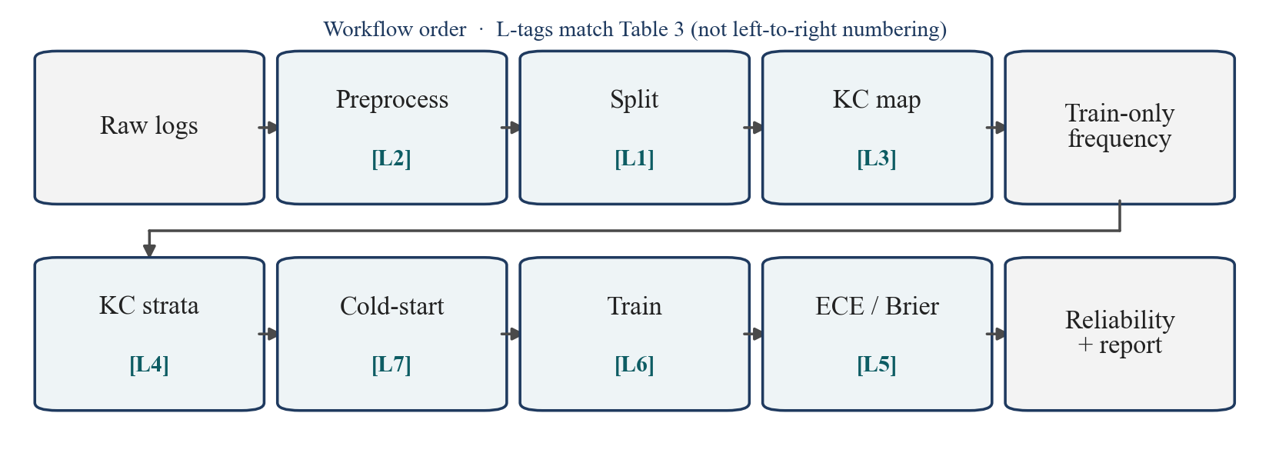
Fig. 1. Reproducible sparse-concept and calibration diagnostic pipeline. Tags L1–L7 match Table 3 (L5: no test-fit map; L6: final checkpoint; L7: f_train=0). Not a new KT architecture.
Table 3. Seven-channel leakage checklist for the evaluation pipeline (learner-based fold 0). PASS means the decision is train-only, validation-only, or a fixed training schedule (L6: final checkpoint). Test is used only to report.
Channel | Decision | Assist. | Junyi | XES3G5M
L1 Split | Learner-disjoint users | PASS | PASS | PASS
L2 Preprocess | Train-only transforms | PASS | PASS | PASS
L3 Q-matrix | Static platform tag | PASS | PASS (ucid) | PASS
L4 Bucket | f_train cuts only | PASS | PASS (empty sparse) | PASS
L5 Calibration | No test-fit map | PASS | PASS | PASS
L6 Hyperparam. | Final checkpoint | PASS | PASS | PASS
L7 Cold-start | f_train=0 documented | PASS (I) | PASS (empty) | PASS (I)
In our implementation, unseen learners trigger a constant/base-rate fallback, yielding AUC=0.50; we report IRT as a base-rate reference, not as a ranking competitor. This fallback is not an inherent property of IRT.

D. Train-only frequency strata
For each fold, KC frequency ftrain is counted on the training file only. Buckets: strict cold-start (f=0), very sparse (0<f<20), sparse (20≤f<100), medium (100≤f<500), dense (f≥500). Fig. 2 (top) shows the number of KCs in each stratum. Training-interaction volume is shown separately in the bottom row from summed ftrain, not inferred from KC counts. The protocol then applies four steps on each fold: (1) assign those train-only strata, including f=0; (2) flag occupancy R/L/I; (3) report ECE/Brier with those flags; (4) optionally apply one locked τ and report FAR with Nadvance as a probe (Section III.E–H).

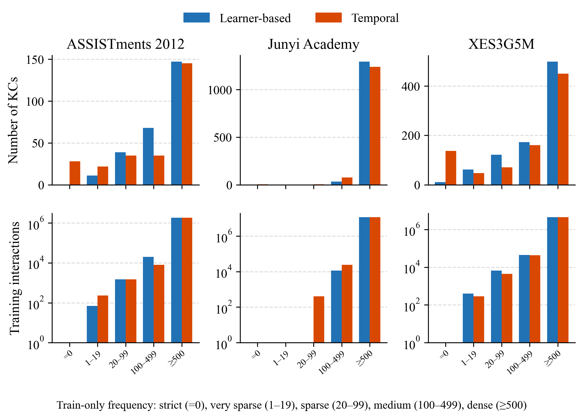
Fig. 2. Distribution of KCs across train-only frequency strata under learner-based and temporal splits. Bottom: verified training-interaction counts (sum of train-only ftrain on fold 0); volume is not inferred from KC counts. Bottom y-axis is logarithmic.

E. Reliability flags
Occupancy flags follow test-event count N: Reliable (R) N≥1000; Limited (L) 100≤N<1000; Insufficient (I) N<100. We call R, L, and I descriptive sample-support flags. They are not inferential guarantees, confidence intervals, or hypothesis tests. Substantive stratum-level interpretations require at least Limited support; Insufficient cells are descriptive only. Very-sparse ASSISTments cells are Insufficient and descriptive only.

F. Calibration
Let y∈{0,1} be next-response correctness and p∈[0,1] the predicted probability. With M=15 equal-width bins, expected calibration error (ECE) is
ECE = Σ_{m} (n_{m} / N) |acc_{m} − conf_{m}| (1)
The Brier score is (1/N) Σ_i (p_i − y_i)². We use the binned Murphy decomposition Brier = UNC − RES + REL [23], with UNC = ȳ(1−ȳ), REL = (1/N) Σ_m n_m (conf_m − acc_m)², and RES = (1/N) Σ_m n_m (acc_m − ȳ)². Because probabilities are binned, the three components are an empirical approximation and need not sum exactly to the directly computed Brier score. Lower ECE is better calibration; it is not a substitute for AUC.

G. Difficulty coupling
For each KC c we define a training-only difficulty proxy difficulty(c) = 1 − mean_train_correctness(c). The mean is taken on the training file only. This is an observational proxy for how often c is answered incorrectly in training; it is not a latent IRT difficulty parameter. The reported Spearman association is ρ(log(1+f_{train}), difficulty), computed on training-fold KC summaries. The same file yields item support (distinct items per KC), learner exposure (distinct learners per KC), and a curriculum-position proxy (median normalized sequence position). Results report between-KC associations and a within-KC sparsification check; neither identifies a causal frequency effect.

H. Simulated decision-error probe (not the primary claim)
For a locked global threshold τ, the system advances (skips remediation) if p≥τ and triggers remediation otherwise. Sparse events never receive their own tuned τ in the display rule: Supplementary Tables S5–S6 use one locked global τ=0.7. On ASSISTments 2012 fold 0, T-KT ΔFAR stays positive at every locked grid point τ∈{0.5, 0.6, 0.7, 0.8} (Supplementary Table S3); the grid is not a search over sparse error. Supplementary Table S4 is a counterfactual on the same frozen p (Reliable-only advance; mixed τ sparse 0.8 / else 0.7), not a trained or displayed mixed-τ rule.
Let A={p≥τ}. The false-advance rate (FAR) is P(y=0 | p≥τ): among responses for which the simulated system would advance the learner, the proportion whose observed next response is incorrect. This is not a measurement of latent mastery. It is a next-response decision-error proxy under a simulated threshold gate. Miss = P(p≥τ | y=0). Expected FAR under the model probabilities is E[1−p | p≥τ]. Excess FAR = FAR − E[1−p | p≥τ]. ΔFAR = FAR_sparse − FAR_dense. FAR is a proportion of N_{advance} = count(p≥τ) events, not of N_total; Miss is a proportion of N_{incorrect} = count(y=0). N_total alone does not imply the precision of FAR. Where prediction-level exports exist, 95% intervals use the KC-clustered percentile bootstrap already used for this gate (B=2000, resample KCs within sparse and within dense). Positive ΔFAR means sparse advance decisions are less reliable than dense advance decisions. This is a simulated decision error, not an instructional randomized controlled trial (RCT).

IV. RESULTS

A. Aggregate discrimination
Table 4 reports overall learner-based area under the ROC curve (AUC) and accuracy (ACC), mean±sd over four unique partitions. This subsection is discrimination, not calibration. DKT is slightly above T-KT on all three datasets (ASSISTments DKT 0.6979±0.0014 versus T-KT 0.6837±0.0025). Official SimpleKT [4] on the same ASSISTments partitions reaches 0.7700±0.0013 (ACC 0.7522±0.0014); T-KT is not that checkpoint. Stratum-level AUC and ACC for IRT, DKT, and T-KT are in Supplementary Table S8. In our implementation, unseen learners trigger a constant/base-rate fallback, yielding AUC=0.5000; it is a base-rate reference, not a ranking competitor.
Table 4. Overall learner-based area under the ROC curve (AUC) and accuracy (ACC) (mean±sd over four unique partitions). Official SimpleKT [4] is reported on ASSISTments only.
Dataset | Model | AUC | ACC
ASSISTments 2012 | IRT | 0.5000 | 0.6973±0.0004
ASSISTments 2012 | DKT | 0.6979±0.0014 | 0.7182±0.0014
ASSISTments 2012 | T-KT | 0.6837±0.0025 | 0.6996±0.0032
ASSISTments 2012 | SimpleKT | 0.7700±0.0013 | 0.7522±0.0014
Junyi Academy | IRT | 0.5000 | 0.7053±0.0018
Junyi Academy | DKT | 0.7320±0.0009 | 0.7343±0.0015
Junyi Academy | T-KT | 0.7231±0.0030 | 0.7274±0.0015
XES3G5M | IRT | 0.5000 | 0.7961±0.0031
XES3G5M | DKT | 0.8180±0.0009 | 0.8321±0.0015
XES3G5M | T-KT | 0.7536±0.0010 | 0.8057±0.0029
On XES3G5M, sparse-stratum AUC is higher than dense-stratum AUC (DKT 0.858 versus 0.818; T-KT 0.847 versus 0.752; Reliable occupancy). Lower training frequency is therefore not a universal ranking failure. Junyi’s learner-based sparse bucket is empty under the pre-specified cuts—a protocol outcome, not a missing cell and not a zero-ECE claim.

B. Calibration across frequency strata
Table 5 reports event-level expected calibration error (ECE), not AUC. On ASSISTments 2012, T-KT ECE increases from 0.1136±0.0066 (dense, Reliable, N=523,971) to 0.1541±0.0051 (medium) to 0.2280±0.0197 (sparse, Limited, N=415). That sparse cell is Limited support, not a high-N finding. Official SimpleKT [4] on those partitions has ECE 0.0203±0.0035 dense and 0.0884±0.0187 sparse (Limited, N=415); the rise remains, and the T-KT cells stay locked. DKT moves in the same direction on this dataset (dense 0.0602±0.0022 versus sparse 0.2333±0.0084). IRT dense ECE is 0.0031±0.0006, but resolution is zero (Supplementary Table S1): a near-constant predictor can look calibrated while providing no ranking information.
Calibration does not universally worsen. On Junyi Academy the learner-based sparse bucket is empty; only dense and medium exist, and T-KT ECE rises from 0.0792±0.0051 to 0.1073±0.0156. On XES3G5M, T-KT ECE is a counter-pattern: essentially flat from dense to sparse (0.1176, 0.1129, 0.1254) despite Reliable sparse occupancy (N=1,969). A flat ECE is not a license to skip occupancy reporting and is not the same as a flat miss rate. Full Brier, reliability, resolution, and uncertainty results are provided in Supplementary Table S1.

Table 5. T-KT and official SimpleKT [4] (ASSISTments only) event-level expected calibration error (ECE) by train-only frequency stratum. N is the mean test-event count across four unique learner partitions, not a single-partition count. Flags: Reliable (R) N≥1000; Limited (L) 100≤N<1000. Junyi sparse is empty.
Dataset | Stratum | N | Flag | ECE
ASSISTments 2012 | dense | 523,971 | R | 0.1136±0.0066
ASSISTments 2012 | medium | 5,963 | R | 0.1541±0.0051
ASSISTments 2012 | sparse | 415 | L | 0.2280±0.0197
Assist. SimpleKT | dense | 523,971 | R | 0.0203±0.0035
Assist. SimpleKT | medium | 5,963 | R | 0.0262±0.0025
Assist. SimpleKT | sparse | 415 | L | 0.0884±0.0187
Junyi Academy | dense | 3,232,614 | R | 0.0792±0.0051
Junyi Academy | medium | 3,836 | R | 0.1073±0.0156
XES3G5M | dense | 1,269,345 | R | 0.1176±0.0014
XES3G5M | medium | 12,889 | R | 0.1129±0.0061
XES3G5M | sparse | 1,969 | R | 0.1254±0.0047

Table 6. Four-partition Brier score and Murphy decomposition (UNC − RES + REL) by train-only stratum. N is the mean test-event count. Junyi sparse is empty. Full Brier, UNC, REL, and RES grids, including XES3G5M, are in Supplementary Table S1.
Dataset | Model | Stratum | N | ECE | Brier | UNC | REL | RES
ASSISTments | DKT | dense | 523,971 | 0.0602 | 0.1931 | 0.2103 | 0.0053 | 0.0223
ASSISTments | DKT | sparse | 415 | 0.2333 | 0.2502 | 0.2337 | 0.0624 | 0.0451
ASSISTments | T-KT | dense | 523,971 | 0.1136 | 0.2116 | 0.2103 | 0.0201 | 0.0186
ASSISTments | T-KT | sparse | 415 | 0.2280 | 0.2525 | 0.2337 | 0.0594 | 0.0392
Junyi | DKT | dense | 3,226,541 | 0.0389 | 0.1804 | 0.2078 | 0.0022 | 0.0294
Junyi | DKT | medium | 3,706 | 0.2513 | 0.3077 | 0.2432 | 0.0741 | 0.0091
Junyi | T-KT | dense | 3,232,614 | 0.0792 | 0.1884 | 0.2079 | 0.0084 | 0.0279
Junyi | T-KT | medium | 3,836 | 0.1073 | 0.2307 | 0.2417 | 0.0149 | 0.0260
Fig. 3. Reliability diagrams (15 equal-width bins; seed 42). Rows: ASSISTments 2012 and Junyi Academy. Columns: DKT and T-KT. ASSISTments panels show dense vs sparse; Junyi panels show dense vs medium (learner-based sparse is empty). Not a classroom trial.

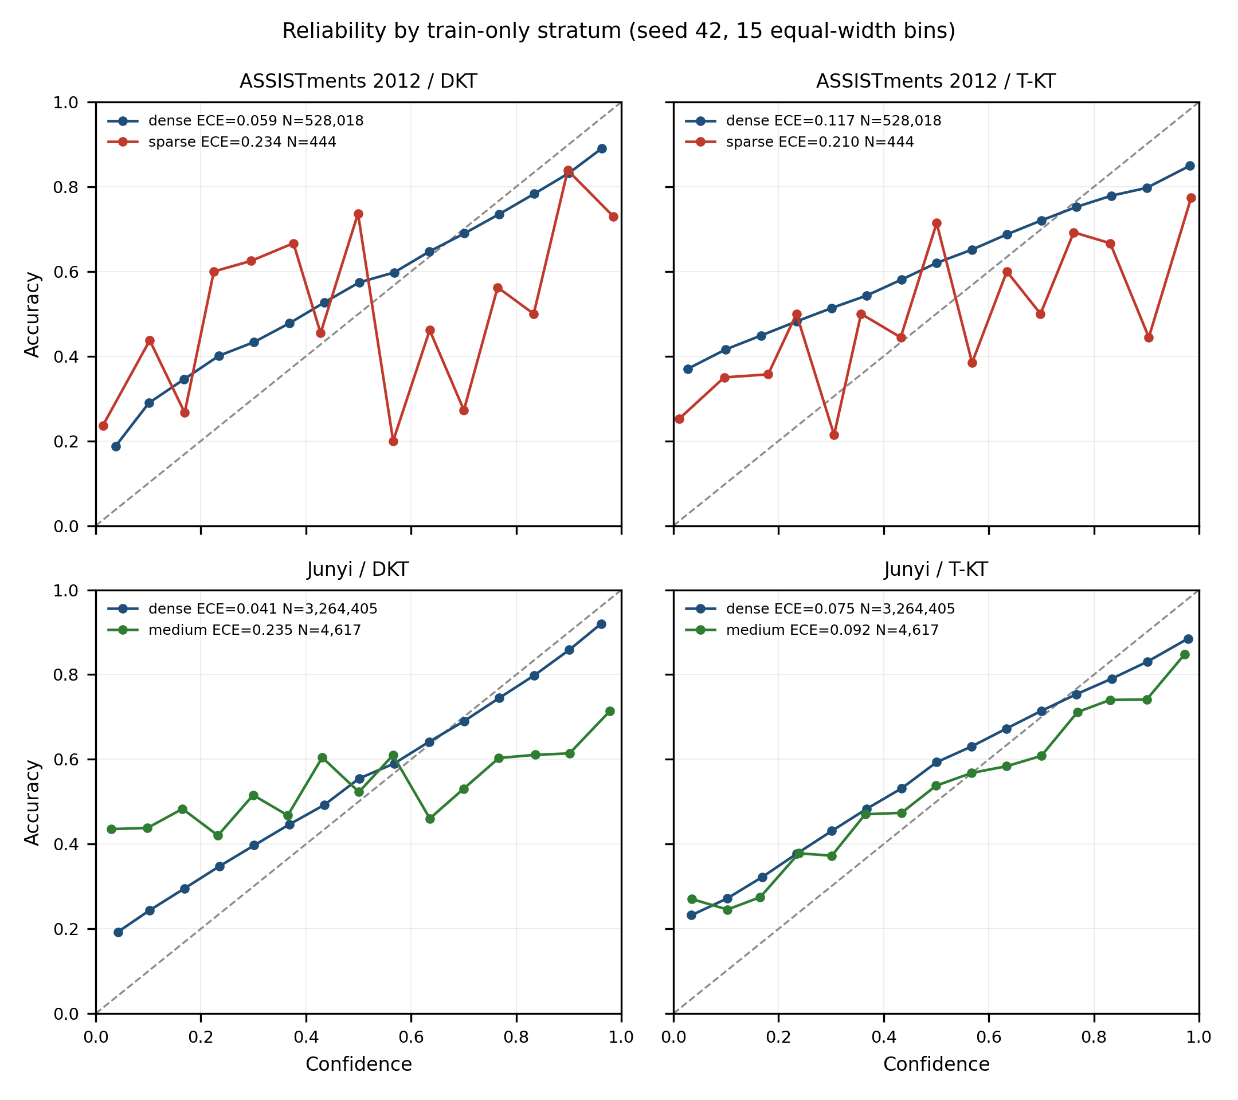

C. Cold-start concept feasibility
Strict cold-start is freq_train(c)=0. The next Table 7 slice is the protocol very-sparse bucket (0<freq_train(c)<20), not a limited cold-start (k5/k10) group. Table 7 reports feasibility, not a production claim. On ASSISTments 2012 the strict bin has about four test events (Insufficient) and the very-sparse bin about 17 events (Insufficient), so ECE/AUC on those slices are descriptive only. Junyi’s learner-based operational identifier (ucid) yields no estimable sparse or strict-cold-start stratum. XES3G5M very-sparse support is larger (N≈114) but still not a high-N finding. Where the strict slice is too small, the protocol records the empty or Insufficient bucket instead of borrowing a recommender user/item cold-start definition.
Table 7. Cold-start concept feasibility (four-partition means). Strict: f_train=0. Very-sparse: 0<f_train<20. L/I are occupancy flags (N), not k5/k10 groups. I = Insufficient (N<100). Not a recommender user/item split. XES3G5M very-sparse uses the same masked four-partition series as Table 5 (N=114).
Dataset | Slice | Mean N | Flag | T-KT ECE | DKT ECE
ASSISTments | strict f=0 | 4 | I | descr. | descr.
ASSISTments | very-sparse | 17 | I | 0.245 | 0.178
Junyi | strict / sparse | 0 | empty | — | —
XES3G5M | very-sparse | 114 | L | 0.184 | 0.173

D. Diagnostic conditions and threshold sensitivity
If a learning platform uses KT probabilities only to sort students, Table 4 may suffice. If it uses p to skip practice or declare mastery, Table 4 is an insufficient evaluation summary. The ASSISTments T-KT cell is an illustrative case: aggregate discrimination that does not reveal the sparse-stratum calibration pattern, Limited-but-estimable sparse occupancy (about 19% of KCs fall below the sparse threshold on fold 0), a monotonic ECE rise, and a gate that yields a higher error rate among sparse advance decisions. The XES3G5M cell is the contrasting case: plenty of low-frequency tail mass (f_train<100) and Reliable occupancy, yet T-KT ECE does not degrade. Junyi shows that the protocol can refuse a sparse claim when the bucket is empty.
The following checks are secondary evidence for why and when a sparse-calibration contrast is estimable; they do not replace the per-stratum ECE and Brier results. Supplementary Table S7 checks the same ASSISTments T-KT dense-to-sparse ECE rise under two alternative train-only cut grids; the sign does not flip. Table 8 separates two questions. E1–E2 determine whether a sparse contrast can be estimated under the protocol thresholds; E3 and other structural descriptors help characterize the direction of the observed pattern. E1 is a non-empty low-frequency tail under the split actually used; E2 is enough sparse test events for at least a Limited-flag ECE. E3 (frequency–difficulty coupling) is not treated as necessary or sufficient for an adverse gradient. Junyi fails E1–E2. ASSISTments and XES3G5M both meet E1–E2, yet only ASSISTments shows a dense-to-sparse T-KT ECE rise.
Table 8. Empirical conditions associated with the availability and direction of sparse-calibration contrasts on the three evaluated datasets. Low-frequency tail mass: share of KCs with train-only frequency ftrain<100. E3 is not necessary or sufficient for an adverse gradient.
Condition | ASSISTments | Junyi | XES3G5M
A. Estimability

Low-frequency tail mass (E1) | 18.9% of KCs | 0% | 22.5% of KCs
Sparse test support (E2) | 415 (L) | empty | 1,969 (R)
B. Observed pattern/context

Difficulty coupling (E3) | ρ=−0.227 (sparse harder) | ρ=−0.416 | ρ=+0.110 (weak, inverted)
Item support | median 44.5 (dense 205 vs sparse 1) | median 18 (IQR 5) | median 3 (dense 9 vs sparse 1)
Curriculum-position coupling | ρ=−0.308 | ρ=−0.324 | ρ=−0.126
Observed T-KT ECE | 0.114→0.228 | dense→medium only | flat 0.1176→0.1254

E. Secondary explanatory analysis
Learner exposure (distinct training learners per KC) enters the regressions below; it is not an E1–E2 estimability criterion. The regression and sparsification checks are not causal claims.
A test-event-weighted KC-level regression of T-KT expected calibration error (ECE) on those five training-only covariates is a between-KC association: it compares different concepts. ASSISTments (478 KC-fold rows; 261 unique KCs) and Junyi (2,645 KC-fold rows; 1,326 unique KCs) use cluster-robust standard errors at kc_id; XES3G5M is 829 unique KCs in the masked weighted fit. Standardized log(1+ftrain) coefficients are −0.068 [−0.086, −0.050] on ASSISTments, −0.014 [−0.018, −0.010] on Junyi, and −0.028 [−0.042, −0.014] on XES3G5M in the weighted fit. Difficulty is independently associated on all three datasets. Learner exposure is independently associated on ASSISTments (+0.016 [0.004, 0.027]) and on XES3G5M (+0.013 [+0.005, +0.021]). These signs do not test a frequency dose on a fixed KC.
Controlled sparsification does not reproduce a universal monotonic frequency effect; complete dataset-model results are in Supplementary Table S2.
The three analyses target different estimands: stratum ECE is an event-weighted coarse-bucket contrast, the regression estimates an adjusted between-KC association, and controlled sparsification evaluates an artificial within-KC reduction of training evidence. Their signs and magnitudes therefore need not coincide.

F. Secondary decision-error probe
A locked gate at τ=0.7 is a simulated next-response decision-error probe, not RQ3. On ASSISTments 2012, T-KT FAR is 0.196 on dense KCs and 0.268 on sparse KCs (ΔFAR=+0.072; seed 42) and is positive in 4/4 unique learner partitions (partition-level mean 0.056). On XES3G5M the same probe is negative. The τ-grid, occupancy-policy counterfactual, denominators, and seed tables are Supplementary Tables S3–S6.

V. DISCUSSION

A. Main empirical findings
Three empirical regularities, not laws, structure the results. First, training frequency is not a universal predictor of AUC failure: on XES3G5M, sparse-stratum AUC is higher than dense-stratum AUC for DKT and T-KT (Reliable occupancy), and Junyi’s learner-based sparse bucket is empty (exercise-level operational identifier, ucid) rather than a ranking collapse. Second, calibration vulnerability is dataset-dependent. ASSISTments 2012 T-KT ECE is associated with a dense-to-sparse rise under Limited sparse support (Table 5, N=415); XES3G5M T-KT ECE is a counter-pattern that stays essentially flat despite Reliable sparse occupancy. Calibration is not guaranteed to worsen as frequency falls. Third, a simulated next-response decision-error probe can differ by frequency stratum: ASSISTments T-KT ΔFAR is positive in 4/4 unique partitions, and the XES3G5M probe is negative (Supplementary Tables S5–S6).

B. Practical implications for educational technology
Educational-technology gates that skip, remediate, or advance practice consume a predicted probability, not a population AUC. A ranking win can therefore hide miscalibration on rarely practiced KCs. This subsection states an evaluation protocol for that probability-to-decision chain; it is not a classroom policy and not a recommended production threshold. The protocol is four checks before using one global KT probability threshold: (i) inspect KC-frequency occupancy on the training fold actually used, including empty buckets; (ii) evaluate per-stratum ECE and Brier separately from AUC; (iii) if a locked gate is simulated, report FAR with its denominators (Supplementary Tables S3–S6); (iv) ensure sufficient sample support before treating a slice as actionable. R/L/I flags are descriptive occupancy labels, not inferential guarantees. This study does not apply temperature scaling [11] or Platt scaling [26]. A population AUC win is not by itself evidence that probabilities are reliable on the tail.

C. Why datasets differ
The three logs differ on E1–E2 estimability and on structural context (Table 8). Junyi’s learner-based sparse bucket is empty because the operational field is ucid (an exercise-level identifier, not a skill tag), so the protocol can refuse a sparse claim when the unit is finer than a skill. Junyi is therefore interpreted primarily as a granularity-and-estimability case rather than direct evidence about pedagogical KC sparsity. ASSISTments and XES3G5M both have a non-empty sparse tail and at least Limited test support, yet T-KT ECE rises on ASSISTments and stays essentially flat on XES3G5M. Frequency–difficulty coupling, item support, and curriculum-position coupling are reported as context, not as necessary or sufficient conditions for that direction. Within-KC sparsification (Supplementary Table S2) does not reproduce the observational ASSISTments T-KT ECE gradient. These are associations on these datasets. Untested explanations—curriculum hierarchy, tagging granularity, ceiling effects, and item semantics—are hypotheses unless experimentally isolated, which this study does not do.

D. Limitations
Next-response correctness is not latent mastery: y=0 is an incorrect next attempt, not a latent-skill diagnosis. The threshold gate is a simulated probe, not a classroom policy. There is no classroom RCT. We do not train graph, contrastive, or self-supervised KT models. BKT is not a scored baseline; IRT is the classical reference (pyBKT 1.4.1 degenerated on ASSISTments seed 42; Supplementary Table S9). T-KT is a local Transformer implementation, not published SimpleKT [4]; official SimpleKT is scored on ASSISTments AUC/ECE only. Temporal evaluation uses a single corrected cutoff (seed 42). Seeds 2025 and 2026 share a split. R/L/I are descriptive support flags. ECE depends on binning. Three datasets cannot establish a universal diagnostic law. The reported diagnostics are reproduced from the frozen review artifact (code_for_review_anonymous.zip) and configuration; locked tables rebuild from frozen summaries (scripts/rebuild_locked_tables.sh).

VI. CONCLUSION
Under the evaluated conditions, KT probabilities that look adequate on aggregate AUC can still be poorly calibrated on sparse KCs in some dataset-model settings. That ECE association appears for T-KT on ASSISTments 2012 (Limited sparse support). It is not reported for Junyi’s empty learner-based sparse bucket, and XES3G5M T-KT ECE remains essentially flat. The train-only strata, leakage checklist, and per-stratum ECE/Brier diagnostics are therefore conditionally useful. Graph and contrastive KT, and any path or distillation module, are left to later studies. This paper is a protocol and calibration diagnostic, not a new KT model and not a classroom intervention.

Conflict of Interest
The authors declare no conflict of interest.

Author Contributions
K.-T.N.: Conceptualization, Methodology, Software, Formal analysis, and Writing (led diagnostic design, experiments, and manuscript). T.D.M. and D.N.T.: Software (data processing and baseline runs). C.T.N.: Methodology (methodological review). V.-H.N.: Supervision and Writing (manuscript revision). All authors approved the final version.

Ethical Statement
This study is a secondary analysis of publicly released, de-identified benchmark educational datasets (ASSISTments 2012, Junyi Academy, and XES3G5M). No new human participants were recruited and no classroom intervention was conducted. The work uses only records already released by the original dataset providers.

Data and Code Availability
Code, data-preprocessing scripts, and evaluation pipelines are available at https:/​/​github.com/​trinhnkt/​Sparse-Concept-and-Calibration. Source benchmark datasets are publicly released by their original providers.

Generative AI Statement
During manuscript preparation, the authors used ChatGPT GPT-6 Astra, Claude Sonnet 5, Google Antigravity 2.12.0, and Cursor Grok 4.6 for language polishing, formatting, consistency checking, and reproducibility-prompt preparation. AI was not used to fabricate or alter experimental results. After using these tools, the authors reviewed and edited the content. The authors remain responsible for all content. Generative AI is not listed as a co-author.

Acknowledgment
This work was supported by the authors’ respective institutions.

References
- A. T. Corbett and J. R. Anderson, “Knowledge Tracing: Modeling the acquisition of procedural knowledge,” User Modeling and User-Adapted Interaction, vol. 4, no. 4, pp. 253–278, 1994. doi: 10.1007/BF01099821
- C. Piech, J. Bassen, J. Huang, S. Ganguli, M. Sahami, L. J. Guibas, and J. Sohl-Dickstein, “Deep Knowledge Tracing,” in Advances in Neural Information Processing Systems, vol. 28, 2015, pp. 505–513.
- G. Abdelrahman, Q. Wang, and B. Nunes, “Knowledge Tracing: A survey,” ACM Computing Surveys, vol. 55, no. 11, pp. 1–37, 2023. doi: 10.1145/3569576
- Z. Liu, Q. Liu, J. Chen, S. Huang, and W. Luo, “SimpleKT: A simple but tough-to-beat baseline for Knowledge Tracing,” in The Eleventh International Conference on Learning Representations, 2023.
- Z. Liu, Q. Liu, J. Chen, S. Huang, J. Tang, and W. Luo, “pyKT: A Python library to benchmark deep learning based Knowledge Tracing models,” in Proc. 36th Conference on Neural Information Processing Systems Datasets and Benchmarks Track, 2022.
- G. Rasch, Probabilistic Models for Some Intelligence and Attainment Tests. Danish Institute for Educational Research, 1960.
- A. Ghosh, N. Heffernan, and A. S. Lan, “Context-aware attentive Knowledge Tracing,” in Proc. ACM SIGKDD Conf. Knowledge Discovery and Data Mining, 2020, pp. 2330–2339. doi: 10.1145/3394486.3403282
- H. Nakagawa, Y. Iwasawa, and Y. Matsuo, “Graph-based Knowledge Tracing: Modeling student proficiency using graph neural network,” in Proc. IEEE/WIC/ACM International Conference on Web Intelligence, 2019, pp. 156–163. doi: 10.1145/3350546.3352513
- W. Lee, J. Chun, Y. Lee, K. Park, and S. Park, “Contrastive learning for Knowledge Tracing,” in Proc. ACM Web Conference, 2022, pp. 2330–2338. doi: 10.1145/3485447.3512105
- R. Pelánek, “Metrics for evaluation of student models,” Journal of Educational Data Mining, vol. 7, no. 2, pp. 1–19, 2015. doi: 10.5281/zenodo.3554665
- C. Guo, G. Pleiss, Y. Sun, and K. Q. Weinberger, “On calibration of modern neural networks,” in Proc. 34th International Conference on Machine Learning, vol. 70, 2017, pp. 1321–1330.
- M. P. Naeini, G. Cooper, and M. Hauskrecht, “Obtaining well calibrated probabilities using Bayesian binning,” in Proc. AAAI Conference on Artificial Intelligence, vol. 29, no. 1, 2015. doi: 10.1609/aaai.v29i1.9602
- G. W. Brier, “Verification of forecasts expressed in terms of probability,” Monthly Weather Review, vol. 78, no. 1, pp. 1–3, 1950. doi: 10.1175/1520-0493(1950)078<0001:VOFEIT>2.0.CO;2
- M. H. DeGroot and S. E. Fienberg, “The comparison and evaluation of forecasters,” The Statistician, vol. 32, no. 1/2, pp. 12–22, 1983. doi: 10.2307/2987588
- X. Yan, C. Tang, and A. Shimada, “Recovering stranded discrimination in Knowledge Tracing: Per-item bias correction via empirical-Bayes shrinkage,” arXiv:2606.14123, 2026, accepted at ECML PKDD 2026. doi: 10.48550/arXiv.2606.14123
- S. Huang, Z. Liu, X. Zhao, W. Luo, and J. Weng, “Towards robust Knowledge Tracing models via k-sparse attention,” in Proc. 46th International ACM SIGIR Conference, 2023, pp. 2441–2445. doi: 10.1145/3539618.3592073
- I. Bhattacharjee and C. Wayllace, “Cold start problem: An experimental study of Knowledge Tracing models with new students,” in Artificial Intelligence in Education (AIED 2025), Lecture Notes in Computer Science, vol. 15880. Springer, 2025, pp. 425–432. doi: 10.1007/978-3-031-98459-4_30
- ASSISTmentsData, “ASSISTments 2012–2013 school data with affect,” ASSISTments Public Datasets, 2012. [Online]. Available: https:/​/​sites.google.com/​site/​assistmentsdata/​datasets/​2012-13-school-data-with-affect
- Junyi Academy, “Junyi Academy online learning activity dataset,” Kaggle, 2019. [Online]. Available: https:/​/​www.kaggle.com/​datasets/​junyiacademy/​learning-activity-public-dataset-by-junyi-academy
- Z. Liu, Q. Liu, T. Guo, J. Chen, S. Huang, X. Zhao, J. Tang, W. Luo, and J. Weng, “XES3G5M: A Knowledge Tracing benchmark dataset with auxiliary information,” in Proc. 37th Conference on Neural Information Processing Systems Datasets and Benchmarks Track, 2023.
- W. Cheng, H. Du, C. Li, E. Ni, L. Tan, T. Xu, and Y. Ni, “Uncertainty-aware Knowledge Tracing,” in Proc. AAAI Conference on Artificial Intelligence, vol. 39, no. 27, pp. 27905–27913, 2025. doi: 10.1609/aaai.v39i27.35007
- J. Mitton, P. Bhattacharyya, R. Abboud, and S. Woodhead, “Knowing when to defer: Selective prediction for responsible Knowledge Tracing,” in Proc. Impactful and Responsible AI Systems for Education Workshop, Proc. Machine Learning Research, vol. 339, 2026, pp. 22–42.
- A. H. Murphy, “A new vector partition of the probability score,” Journal of Applied Meteorology, vol. 12, no. 4, pp. 595–600, 1973. doi: 10.1175/1520-0450(1973)012<0595:ANVPOT>2.0.CO;2
- S. E. Fancsali, T. Nixon, and S. Ritter, “Optimal and worst-case performance of mastery learning assessment with Bayesian Knowledge Tracing,” in Proc. 6th International Conference on Educational Data Mining, 2013, pp. 35–42.
- J. Zhang, R. Das, R. S. Baker, and R. Scruggs, “Knowledge tracing models’ predictive performance when a student starts a skill,” in Proc. 14th International Conference on Educational Data Mining, 2021, pp. 625–629.
- J. Platt, “Probabilistic outputs for support vector machines and comparisons to regularized likelihood methods,” in Advances in Large Margin Classifiers, 1999, pp. 61–74.
Copyright © 2026 by the authors. This is an open access article distributed under the Creative Commons Attribution License which permits unrestricted use, distribution, and reproduction in any medium, provided the original work is properly cited (CC BY 4.0).

